EXPERIMENT: 3
DATE:14.07.26

Water Jug Problem using Breadth-First Search (BFS)
Aim:
To write a Python program to solve the Water Jug Problem using the Breadth-First Search (BFS) algorithm.

Algorithm:
- Read the capacities of Jug 1 and Jug 2, and the target amount.
- Start with both jugs empty.
- Create a queue and insert the initial state (0,0).
- Generate all possible next states:
  - Fill Jug 1
  - Fill Jug 2
  - Empty Jug 1
  - Empty Jug 2
  - Pour water from Jug 1 to Jug 2
  - Pour water from Jug 2 to Jug 1
- Mark each visited state to avoid repetition.
- Repeat until the target amount is obtained in either jug.
- Display the sequence of states.

Program :
from collections import deque

def water_jug(jug1, jug2, target):
visited = set()
queue = deque([((0, 0), [(0, 0)])])
while queue:
(a, b), path = queue.popleft()
if a == target:
return path
if (a, b) in visited:
continue
visited.add((a, b))
next_states = [
(jug1, b), # Fill Jug1
(a, jug2), # Fill Jug2
(0, b), # Empty Jug1
(a, 0), # Empty Jug2
]
# Pour Jug1 -> Jug2
transfer = min(a, jug2 - b)
next_states.append((a - transfer, b + transfer))
# Pour Jug2 -> Jug1
transfer = min(b, jug1 - a)
next_states.append((a + transfer, b - transfer))
for state in next_states:
if state not in visited:
queue.append((state, path + [state]))
return None
jug1 = int(input("Enter capacity of Jug 1: "))
jug2 = int(input("Enter capacity of Jug 2: "))
target = int(input("Enter target amount: "))
solution = water_jug(jug1, jug2, target)
if solution:
print("\nSteps to reach the target:\n")
for step in solution:
print(step)
else:
print("No solution exists.")

Output:
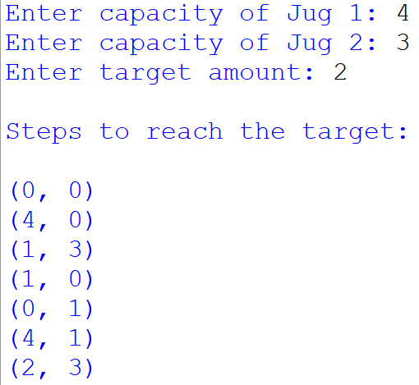

Result:
Thus, the Python program to solve the Water Jug Problem using Breadth-First Search (BFS) was successfully executed, and the target amount was obtained in Jug 1.

